EXPERIMENT NO. 5: ONLINE FLIGHT RESERVATION SYSTEM
AIM:
To design and develop a web-based online flight reservation application supporting flight search across airlines, real-time cabin class seat availability, booking transactions, printable e-ticket generation, and administrative schedule controls.
PSEUDOCODE (IN 6 SIMPLE POINTS):
Step 1: Initialize flight inventory database with flight numbers, departure cities, destinations, airlines, and cabin classes.
Step 2: Accept passenger search parameters including departure airport, arrival airport, flight date, and travel class.
Step 3: Display available flights showcasing airline logos, departure/arrival schedules, flight durations, and prices.
Step 4: Capture traveler passport or national ID details along with meal and baggage preferences.
Step 5: Execute simulated credit card/payment gateway processing and generate a verified booking confirmation code.
Step 6: Render an e-ticket containing flight details, boarding pass barcode simulator, and admin route update modules.
SOURCE CODE:
<!DOCTYPE html>
<html lang="en">
<head>
<meta charset="UTF-8">
<title>SkyWings Airline Reservation</title>
<style>
body { font-family: 'Segoe UI', Tahoma, sans-serif; margin: 0; background: #0f172a; color: #f8fafc; }
.header { background: #1e293b; padding: 20px 40px; display: flex; justify-content: space-between; border-bottom: 2px solid #38bdf8; }
.container { max-width: 950px; margin: 30px auto; background: #1e293b; padding: 30px; border-radius: 12px; box-shadow: 0 4px 20px rgba(0,0,0,0.5); }
.search-box { display: grid; grid-template-columns: repeat(4, 1fr); gap: 15px; margin-bottom: 25px; }
input, select, button { padding: 12px; border-radius: 6px; border: 1px solid #475569; background: #0f172a; color: white; box-sizing: border-box; width: 100%; }
button { background: #38bdf8; color: #0f172a; font-weight: bold; border: none; cursor: pointer; }
button:hover { background: #0284c7; color: white; }
.flight-card { background: #334155; padding: 20px; border-radius: 8px; margin-bottom: 15px; display: flex; justify-content: space-between; align-items: center; }
.flight-time { font-size: 18px; font-weight: bold; color: #38bdf8; }
.eticket { background: white; color: #0f172a; padding: 25px; border-radius: 8px; margin-top: 25px; border-left: 6px solid #38bdf8; }
</style>
</head>
<body>
<div class="header">
<h2>SkyWings Global Airways</h2>
<span>Real-Time Flight Booking</span>
</div>
<div class="container">
<h3>Book International & Domestic Flights</h3>
<div class="search-box">
<input type="text" id="origin" placeholder="From (e.g. DEL - Delhi)">
<input type="text" id="dest" placeholder="To (e.g. DXB - Dubai)">
<input type="date" id="fDate">
<select id="cabin">
<option value="Economy">Economy Class</option>
<option value="Business">Business Class</option>
</select>
</div>
<button onclick="searchFlights()">Search Flights</button>
<div id="flightResults" style="margin-top: 25px; display: none;">
<div class="flight-card">
<div>
<h4>SkyWings SW-402 &bull; Boeing 787</h4>
<div class="flight-time">08:30 AM &rarr; 11:45 AM (3h 15m)</div>
<small>Non-stop | Baggage: 25 Kg included</small>
</div>
<div style="text-align: right;">
<div style="font-size: 22px; font-weight: bold; margin-bottom: 8px;">Rs. 14,500</div>
<button onclick="bookFlight('SW-402', 14500)" style="width: auto; padding: 8px 18px;">Select Flight</button>
</div>
</div>
</div>
<div id="passengerSection" style="display: none; margin-top: 20px; border-top: 1px solid #475569; padding-top: 20px;">
<h4>Traveler Details</h4>
<div style="display: flex; gap: 15px;">
<input type="text" id="paxName" placeholder="Full Name as per Passport">
<input type="text" id="passportNo" placeholder="Passport / Govt ID No">
<button onclick="issueETicket()" style="max-width: 220px;">Confirm & Pay</button>
</div>
</div>
<div id="ticketContainer"></div>
</div>
<script>
let selectedFlight = null;
function searchFlights() {
document.getElementById('flightResults').style.display = 'block';
}
function bookFlight(flightNo, fare) {
selectedFlight = { flightNo, fare, date: document.getElementById('fDate').value, cabin: document.getElementById('cabin').value };
document.getElementById('passengerSection').style.display = 'block';
}
function issueETicket() {
let name = document.getElementById('paxName').value.trim();
let id = document.getElementById('passportNo').value.trim();
if(!name || !id) return alert('Please enter passenger details');
let pnr = 'SKW' + Math.floor(100000 + Math.random() * 900000);
document.getElementById('ticketContainer').innerHTML = `
<div class="eticket">
<h3 style="color:#0284c7; margin-top:0;">Official E-Ticket / Boarding Confirmation</h3>
<p><b>Booking Reference (PNR):</b> <span style="font-size:18px; color:#e11d48; font-weight:bold;">${pnr}</span></p>
<p><b>Passenger:</b> ${name} | <b>ID/Passport:</b> ${id}</p>
<p><b>Flight:</b> ${selectedFlight.flightNo} | <b>Cabin Class:</b> ${selectedFlight.cabin} | <b>Date:</b> ${selectedFlight.date}</p>
<p><b>Total Fare Paid:</b> Rs. ${selectedFlight.fare.toLocaleString()}</p>
<div style="background:#0f172a; color:white; padding:8px 15px; border-radius:4px; display:inline-block; font-family:monospace;">
BARCODE: ||||| | |||| ||| ||||||| | ||||| [GATE 4B]
</div>
</div>`;
}
</script>
</body>
</html>
Output:
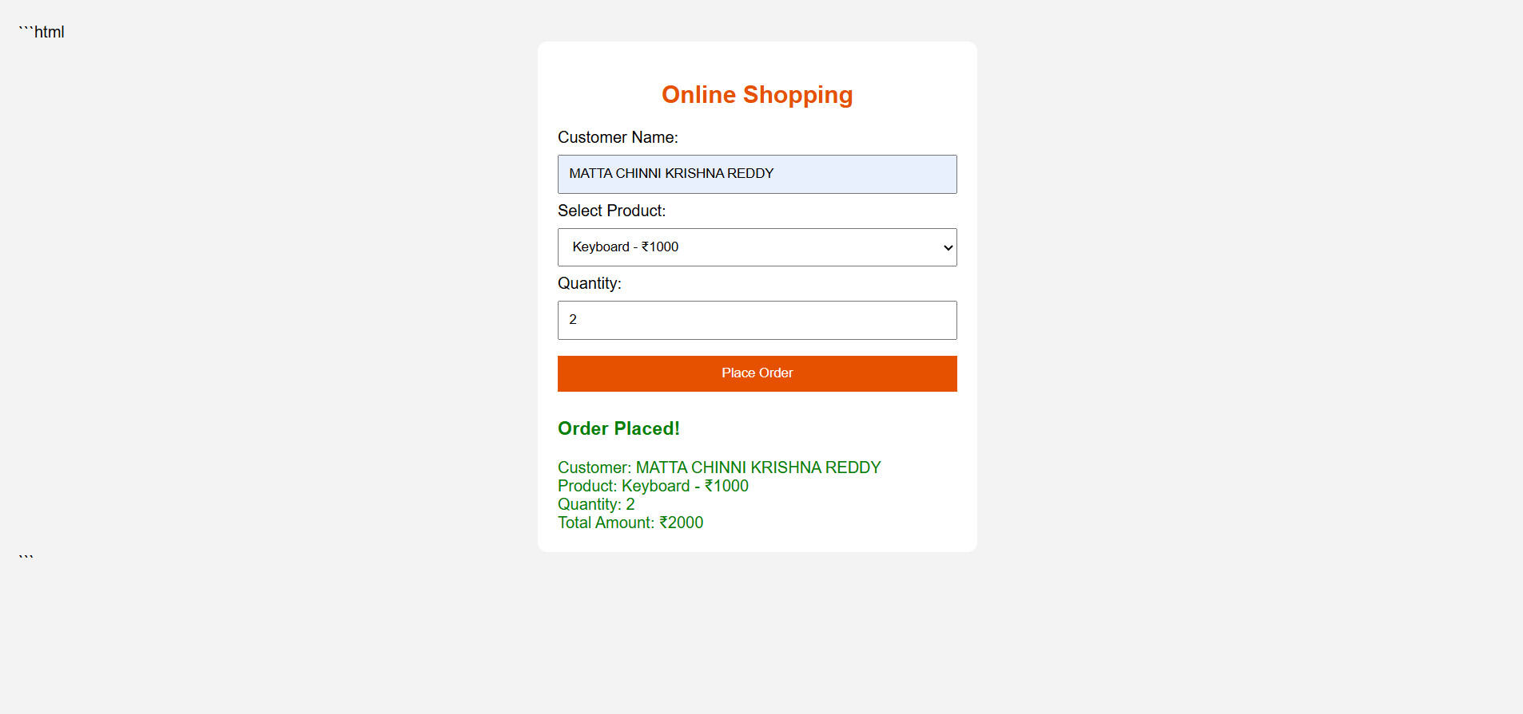
RESULT:
Thus, the online flight reservation system was successfully developed and verified, enabling flight route lookups, passenger seat reservation, payment simulation, and electronic ticket generation.

